

Present Truth
#226

Dear Brothers and Sisters,
“Grace to you, and peace, from God our Father and the Lord Jesus Christ” (Philemon 1:3). God has given you His peace in Christ. Seek Him with all your heart, and you will never regret it.
You are Invited to our non-denominational Bible studies in Siloam Springs, Arkansas on Saturdays and Tuesdays at 7pm. You can also join us on Zoom.com or by phone at 929-205-6099, ID 434-675-5506. Call 304-633-5411 for more info.

In This Issue:

The Three Angels’ Messages (Part 2)
by Lynnford Beachy

Better
by Skylah Rose

Edible Wild Plants
by Lynnford Beachy

Letters from our Readers

Florida Camp Meeting

Kids’ Korner
_______________________________________________________________________________

The Three Angels’ Messages (Part 2)
by Lynnford Beachy

Revelation chapter 13 tells us about the mark of the beast. Here we are warned against receiving the mark, and worshipping the beast or his image. This mark will be enforced by prohibiting buying and selling, and by a death penalty (verses 13-17). It is a terrible crisis that is very soon to come upon this earth. The stage for this crisis is now being set with lockdowns, stay-at-home orders, business closures, mask mandates, mandatory medical injections (Revelation 18:23 check “sorceries” in Greek), digital IDs, social credit scores, and a push for a digital monetary system that can monitor and control every transaction. Those who are faithful to God will not bow down to the image of the beast, nor receive his mark in their foreheads or in their hands.
Right after we are given the warning of the mark of the beast in Revelation 13, chapter 14 portrays three angels who give three messages that, if heeded, will be our safeguard during this crisis.

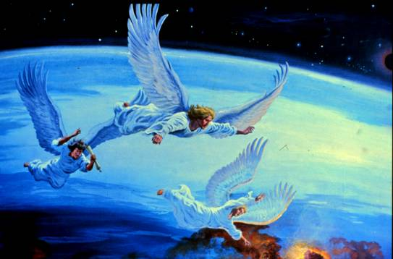

The Bible says, “And I saw another angel fly in the midst of heaven, having the everlasting gospel to preach unto them that dwell on the earth, and to every nation, and kindred, and tongue, and people, Saying with a loud voice, Fear God, and give glory to him; for the hour of his judgment is come: and worship him that made heaven, and earth, and the sea, and the fountains of waters. And there followed another angel, saying, Babylon is fallen, is fallen, that great city, because she made all nations drink of the wine of the wrath of her fornication. And the third angel followed them, saying with a loud voice, If any man worship the beast and his image, and receive his mark in his forehead, or in his hand, The same shall drink of the wine of the wrath of God, which is poured out without mixture into the cup of his indignation; and he shall be tormented with fire and brimstone in the presence of the holy angels, and in the presence of the Lamb: And the smoke of their torment ascendeth up for ever and ever: and they have no rest day nor night, who worship the beast and his image, and whosoever receiveth the mark of his name. Here is the patience of the saints: here are they that keep the commandments of God, and the faith of Jesus” (Revelation 14:6-12).
This passage is known as the three angels’ messages. In part one of this study, we examined what it means to 1) Fear God, 2) Give glory to Him, and 3) Worship Him Who created everything. If you have not read that study, please take the time to read it. You can request a free printed copy, email version, or you can read it on our website: https://presenttruth.info/the-three-angels-messages-part-1-225. I am confident it will be a blessing to you.
Our study in this issue is a continuation of the one in #225, and will be focusing on the second angel’s message. This message says, “Babylon is fallen, is fallen, that great city, because she made all nations drink of the wine of the wrath of her fornication” (Revelation 14:8).

What is Babylon?
The first two times the Hebrew word בבל was used in the Bible it was translated “Babel.” (The remaining 260 times it was translated: “Babylon” or “Babylonian.”) So, we are reading about the very same thing whether it was translated “Babel” or “Babylon.”
Of the origin of Babylon, the Bible says: “And Cush begat Nimrod: he began to be a mighty one in the earth. He was a mighty hunter before the Lord: wherefore it is said, Even as Nimrod the mighty hunter before the Lord. And the beginning of his kingdom was Babel [Babylon],…” (Genesis 10:8-10).
Nimrod was the first leader of Babylon. The meaning of his name is “rebellion” (Brown-Driver-Brigg’s Hebrew Lexicon). He was a rebel! The Bible says, “He was a mighty hunter before the Lord.” The Greek Septuagint says “He was a mighty hunter against the Lord.” The Greek word translated “against” means, “over against, opposite… opposed as an adversary, hostile, antagonistic in feeling or act, an opponent” (Thayer’s Greek Lexicon). Nimrod was a rebellious opponent against God, “And the beginning of his kingdom was Babel [Babylon]” (Genesis 10:10).
The city of Babylon, and the name “Babylon,” continues to represent rebellion against God, along with confusion (as we will see in a moment). It even represents the first rebel against God, Satan himself. The Bible declares that Satan is the ultimate king of Babylon. God said to Isaiah, “…take up this proverb against the king of Babylon,… How art thou fallen from heaven, O Lucifer, son of the morning! how art thou cut down to the ground, which didst weaken the nations! For thou hast said in thine heart, I will ascend into heaven, I will exalt my throne above the stars of God: I will sit also upon the mount of the congregation, in the sides of the north: I will ascend above the heights of the clouds; I will be like the most High. Yet thou shalt be brought down to hell, to the sides of the pit” (Isaiah 14:4, 12-15). So, when the Bible talks about Babylon, it is talking about a kingdom used by the devil to fight against God and His people.

The Tower of Babel
The Tower of Babel is really the tower of Babylon, a tower built that symbolized rebellion against God, and a human attempt to “reach unto heaven” without God (Genesis 11:4). God did something interesting to foil their plans. “And the Lord said, Behold, the people is one, and they have all one language; and this they begin to do: and now nothing will be restrained from them, which they have imagined to do. Go to, let us go down, and there confound their language, that they may not understand one another’s speech. So the Lord scattered them abroad from thence upon the face of all the earth: and they left off to build the city. Therefore is the name of it called Babel [Babylon]; because the Lord did there confound the language of all the earth: and from thence did the Lord scatter them abroad upon the face of all the earth” (Genesis 11:6-9).
The name Babel or Babylon means: “confusion (by mixing)” (Brown-Driver Brigg’s Hebrew Lexicon). Babylon is a system of confusion that continues to this day. It is a Babylonian concept to mix things up to bring confusion. You can see it today in the mixing of genders, as well as in the mixing of pagan religions with Christianity especially manifested in the Papal Roman Catholic System. I was visiting India a few years ago; a country whose primary religion is pagan Hinduism. On almost every block of larger cities there is a shrine dedicated to a pagan god. They could honor a different god on every corner and not run out of deities to honor, since they believe in millions of gods. In front of many of these statues there are two blue peacocks. In Southern India I visited a Catholic Church next to where the Apostle Thomas is thought to have been killed. Inside, at the front of the church, was a statue of Jesus with two blue peacocks on each side. With all the gold and silver ornaments throughout the church, it looked very similar to the shrines all around the cities. I thought to myself that a Hindu worshipper would feel right at home in that Catholic Church. I have heard from others that this practice is done in every place pagan religions are dominant.

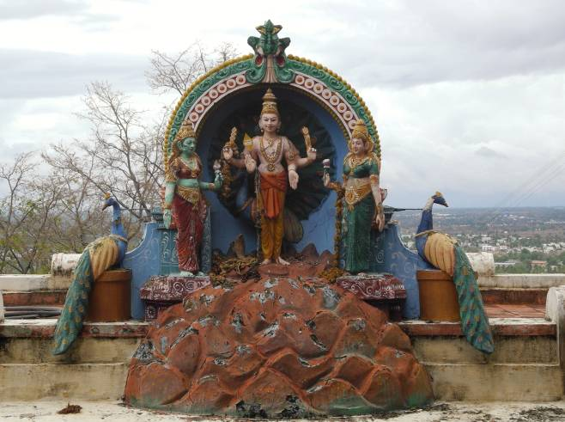

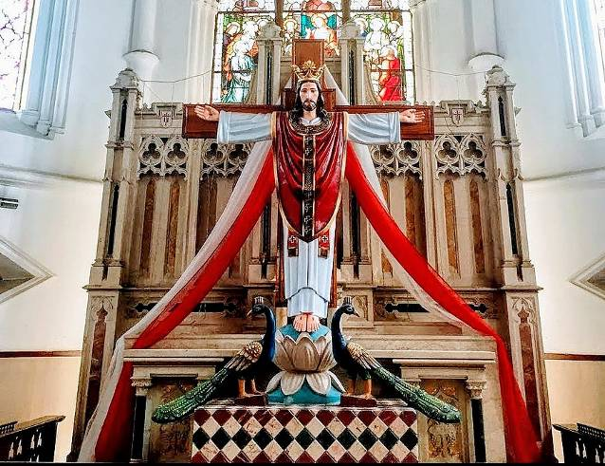

The reason there is such a similarity between the Roman Catholic Church and pagan religions is that this was done on purpose. Shortly after Jesus died, Christianity spread to many parts of the world through the ministry of the apostles. The Roman government saw this as a threat to their power and Christians were brutally persecuted. The Roman Coliseum in Rome, Italy, was used to torture and kill Christians in vast numbers. The Roman Emperor Nero (AD 54 to 68) was, arguably, the most prominent persecutor of Christians. This hatred for Christianity continued in the Roman government for many years.
However, in AD 306 the Roman Emperor Constantine came to power, and he decided to try a different strategy. He was determined to eliminate the persecution of Christians by uniting paganism with Christianity. In some ways his plan was pretty successful; paganism and Christianity were merged in the Roman Catholic Church system. However, more Christians died and were persecuted at the hands of the Roman Catholic Church than at the hands of all of the pagan Roman Emperors combined. So, Constantine’s plan to bring unity and stop the persecution of Christians actually resulted in making things worse.
Regarding the merging of paganism with Christianity, you may be surprised to learn that the famous statue of St. Peter in St. Peter’s Basilica at the Vatican is actually a pagan idol. According to the Catholic Encyclopedia this statue “was originally, in all probability, an ancient consular statue [deified Roman ruler] which was transformed into a representation of the Prince of Apostles” (Catholic Encyclopedia, article: Portraits of the Apostles, online at www.newadvent.org/cathen/12294b.htm). Millions of Catholics have kissed the feet of this statue thinking it was an image of Peter, when in reality it is a pagan statue with a new name. I am glad God is merciful to those who ignorantly worship incorrectly. Keep in mind though that there is a time when God calls for repentance and change (Acts 17:30).

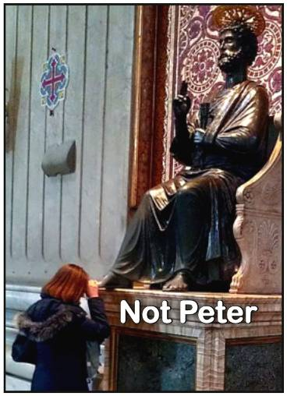

Along with items from pagan temples, came pagan teachings as well. (For a detailed explanation of the merging of paganism and Christianity read The Two Babylons, by Alexander Hislop, available as a pdf for free here: www.ldolphin.org/PDFs/The_ Two_Babylons-Alexander_Hislop.pdf).

Sunday Worship
One of the earliest things Constantine did to merge Christianity with paganism was to enact a law that nobody was allowed to work on Sunday, the first day of the week. For the pagans who worshipped the sun, this day was already venerated. Some Christians also had begun worshipping on “the venerable day of the sun.” However, the early Christians primarily kept the seventh-day Sabbath, and continued this practice for many years after Christ died. In fact, the day after His death, Jesus’ disciples “rested the sabbath day according to the commandment” (Luke 23:56). This day was then, and is now, Saturday, the seventh-day of the week. The disciples were oblivious to any change in the day of worship.
Constantine’s Sunday law was enacted in AD 321, stating:
“Let all the judges and town people, and the occupation of all trades, rest on the venerable day of the sun: but let those who are situated in the country, freely and at full liberty, attend to the business of agriculture; because it often happens that no other day is so fit for sowing corn and planting vines; lest the critical moment being let slip, men should lose the commodities granted by Heaven” (Encyclopedia Britannica, article “Sunday”).
This Sunday law was strictly and completely a religious law, and could only be a religious law. This Sunday law was enacted to benefit pagan sun worshipers. It also contributed to spreading Sunday observance as a religious holiday among Christians.
Notice what one historian has to say about this:
“Centuries of the Christian era passed away before the Sunday was observed by the Christian church as a Sabbath. History does not furnish us with a single proof or indication that it was at any time so observed previous to the Sabbatical edict of Constantine in A.D. 321” (Sir Wm. Domville, Examination of the Six Texts, page 291 as quoted in History of the Sabbath and First Day of the Week, page 344, by John N. Andrews, Steam Press 1873).
A prominent Catholic Catechism boldly admits:
“Q. Which is the Sabbath day?
“A. Saturday is the Sabbath day.
“Q. Why do we observe Sunday instead of Saturday?
“A. We observe Sunday instead of Saturday because the Catholic church, in the counsel of Laodicea (336 A.D.) transferred the solemnity from Saturday to Sunday” (The Convert’s Catechism of Catholic Doctrine, Second Edition, by Peter Geirman, page 50).
Not only is the Catholic Church bold enough to admit that they attempted to change the Sabbath to Sunday, but they claim that it is the mark of their authority. “Sunday is the mark of our authority. The church is above the Bible, and this transference of Sabbath observance is proof of the fact” (The Catholic Record, London, Ontario, September 1, 1923). “Of course the Catholic Church claims that the change was her act. And the act is a mark of her ecclesiastical power and authority in religious matters” (Thomas, H.F., Chancellor of Cardinal Gibbons, in answer to a letter regarding the change of the Sabbath). “The observance of Sunday by the Protestants is an homage they pay, in spite of themselves, to the authority of the [Catholic] Church” (Monsignor Louis Segur, Plain Talk about the Protestantism of Today, page 213).
It is amazing how boldly the papacy admits to their attempted change of one of God’s Ten Commandments that He spoke with His mouth and wrote with His own finger (Exodus 20:1-19; 31:18). Interestingly, the Bible foretold this would happen. The book of Daniel uses the symbol of a “little horn” on a beast to describe the papal Roman power. Here, the Bible says, “And he shall speak great words against the most High, and shall wear out the saints of the most High, and think to change times and laws:…” (Daniel 7:25). The papacy cannot literally change God’s law about time, but He thinks he has this authority.

An Even Bigger Change
The papal attempt to change God’s Sabbath Commandment is terrible enough, but there is something even more significant that she tried to change. The papacy instituted Sunday observance in honor of the god they worship. The Catholic Church claims, “[Sunday] is a day dedicated by the Apostles to the honor of the most holy Trinity,…” (Douay Catechism, page 143). Those who pay homage to the papacy by keeping Sunday are doing so “in honor of the most holy Trinity” (Ibid.) Observance of a holy day is a manner in which people worship God—it is the how of worship, not the who. Sunday observance was instituted by the Roman Catholic Church in honor of their god, the Trinity. The Trinity is who is worshiped through Sunday observance.
The history of how the Trinity doctrine came about is very interesting, and will likely be surprising to you. On page 11 of the book, Handbook for Today’s Catholic, we read,
“The mystery of the Trinity is the central doctrine of the Catholic Faith. Upon it are based all the other teachings of the Church… The Church studied this mystery with great care and, after four centuries of clarification, decided to state the doctrine in this way: in the unity of the Godhead there are three Persons,—the Father, the Son, and the Holy Spirit…”
It wasn’t until about 400 years after Christ died that the Trinity doctrine was formulated as a Christian teaching. That means it was unknown to the apostles who wrote the New Testament. That should be very alarming!
The rise of the Trinity doctrine was predicted in the Bible many years earlier. Speaking of the rise of the papacy, the angel Gabriel told Daniel, “And the king shall do according to his will; and he shall exalt himself, and magnify himself above every god, and shall speak marvellous things against the God of gods, and shall prosper till the indignation be accomplished: for that that is determined shall be done. Neither shall he regard the God of his fathers, nor the desire of women, nor regard any god: for he shall magnify himself above all” (Daniel 11:36, 37). This description of the papacy is almost identical to Paul’s description in 2 Thessalonians 2:3, 4.)
Notice, Gabriel said that when the papacy comes to power it will disregard the God of his fathers. In other words, the God of Abraham, Isaac, and Jacob, the God of Peter, Paul, and the other apostles, would be disregarded by the papacy. Gabriel continued, “But in his estate shall he honour the God of forces: and a god whom his fathers knew not shall he honour with gold, and silver, and with precious stones, and pleasant things. Thus shall he do in the most strong holds with a strange god, whom he shall acknowledge and increase with glory: and he shall cause them to rule over many, and shall divide the land for gain” (Daniel 11:38, 39).

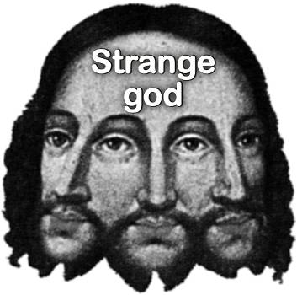

Just as prophesied in the Bible, when the papacy came to power, the “God of [their] fathers” was disregarded, and a “strange god” emerged whom their “fathers knew not.” This prophecy was fulfilled to the letter when Satan inspired the papacy to invent and adopt the Trinity doctrine in the fourth century. (For a study on the history of this doctrine, request a free copy of God’s Love on Trial and The Formulation of the Doctrine of the Trinity. For a thorough Bible study on the Father, Son, and Holy Spirit, request a free copy of Understanding the Personality of God.)
Notice what God says about those who worship strange gods. “They provoked him to jealousy with strange gods, with abominations provoked they him to anger. They sacrificed unto devils, not to God; to gods whom they knew not, to new gods that came newly up, whom your fathers feared not” (Deuteronomy 32:16, 17). When people worship the strange god of the papacy, Satan gets what he so desperately desires—worship (Matthew 4:8, 9). Many people have worshipped this god without realizing where it came from. Thank God that He is merciful and always treats us better than we deserve (Ezra 9:13). The Bible says, “And the times of this ignorance God winked at; but now commandeth all men every where to repent” (Acts 17:30). Ignorance about history may get you God’s mercy, but He still wants us to learn and grow, especially as we draw closer to Christ’s second coming. Now, it is time to repent and make some changes. He gave us His word to be used and appreciated.

The Beginning of Pagan Worship
All pagan religions can trace their roots back to the founder of Babylon, Nimrod. After her husband died, his widowed wife, Semiramis, concocted a scheme to explain her out-of-wedlock pregnancy. She claimed that after Nimrod’s death he had gone up to heaven to become the sun god. She claimed that he had mated with her as a god to produce her son, Tammuz, who was part divine and part human. Thus began the first pagan trinity, after which all others are patterned.
In Babylon, the trinity was Nimrod, Semiramis, and Tammuz. In Egypt, it was Osiris, Horus, and Isis (or Ra). In Greece, there was Zeus, Apollo, and Athena. In India, they worship Brahma, Vishnu, and Shiva. In Rome, it was Jupiter, Mars, and Venus. In all these nations they had the same basic concepts with different names.
Sadly, the Israelites often copied their pagan neighbors. “They provoked him to jealousy with strange gods, with abominations provoked they him to anger. They sacrificed unto devils, not to God; to gods whom they knew not, to new gods that came newly up, whom your fathers feared not” (Deuteronomy 32:16, 17). The Israelites participated in pagan worship, which is the worship of devils. The Bible says, “But I say, that the things which the Gentiles sacrifice, they sacrifice to devils, and not to God: and I would not that ye should have fellowship with devils” (1 Corinthians 10:20).

The Importance of True Worship
Jesus said, “But the hour cometh, and now is, when the true worshippers shall worship the Father in spirit and in truth: for the Father seeketh such to worship him. God is a Spirit: and they that worship him must worship him in spirit and in truth” (John 4:23, 24). In the end there will be true and false worship. You better make sure you are a true worshipper. False worshippers will worship “ye know not what” (John 4:22).
Since the crisis in the end will be over true and false worship (Revelation 13:1-18; 14:7), it is critically important that you know who and what you worship. In the end, “…the people that do know their God shall be strong, and [take action ESV]” (Daniel 11:32). Paul warned that some will preach, “another Jesus” leading people to receive “another spirit” (2 Corinthians 11:4).
Sadly, much of the Christian world today worships a “God” whom they do not know, and “another Jesus” contrary to what the Bible reveals. Very soon it will be even more vitally important for you to know whom you worship. The most important aspect we must know is God’s character of love revealed when He “sent His only begotten Son into the world” to die “for us” (1 John 4:9; Romans 5:8). It is the reality of God’s love in truly giving His only begotten Son to die for us that is the primary attack of Satan, because He does not want people to know how deeply God loves them.

Babylon in the End
The merging of Christianity and paganism in the Catholic church was described in several ways in the Bible, such as “the little horn,” the “Antichrist,” “the Man of Sin,” “the Beast,” and “the Mother of Harlots” (Daniel 7:24, 25; 1 John 2:22, 4:3; 2 Thessalonians 2:3, 4; Daniel 11:36-39; Revelation 13:1-10; 17:5). Because she emulates the characteristics of historic Babylon (rebellion and confusion by mixing), she is also called “Babylon” (Revelation 17:5).
Have you noticed how most of the countries of the world have agreed to follow a unified plan in response to many things, including the latest medical crisis? (See https://youtu.be/_fHfgU8oMSo https://youtu.be/k9DFHRNKbk8. I have seen newscasts from around the world where they all seem to be reading the same script.) The joint actions of the world make it seem like there is some background entity orchestrating the whole response? The Bible says of “Babylon the Great,” that it is “that great city, which reigneth over the kings of the earth” (Revelation 17:5, 18).

The Fall of Babylon
Babylon the great is already in a fallen condition because it is not what it pretends to be, “Christian.” However, it will fall literally as well. The Bible says, “Babylon is fallen, is fallen, that great city, because she made all nations drink of the wine of the wrath of her fornication” (Revelation 14:8). So, the reason Babylon is fallen is because she made all nations drink her polluted wine. The Bible also says, “Babylon the great is fallen, is fallen, and is become the habitation of devils, and the hold of every foul spirit, and a cage of every unclean and hateful bird. For all nations have drunk of the wine of the wrath of her fornication, and the kings of the earth have committed fornication with her, and the merchants of the earth are waxed rich through the abundance of her delicacies” (Revelation 18:2, 3). God still has some of His people in fallen Babylon, but He wants them to come out.
The wine of Babylon is something that she makes all nations drink, and it is this “wine… of her fornication” that causes her to “become the habitation of devils, and the hold of every foul spirit, and a cage of every unclean and hateful bird.” So, what is this wine? It is said to be “the wine… of her fornication.” The first time the word “fornication” is found in the Bible is 2 Chronicles 21:10, 11, where we read: “So the Edomites revolted from under the hand of Judah unto this day. The same time also did Libnah revolt from under his hand; because he had forsaken the Lord God of his fathers. Moreover he made high places in the mountains of Judah, and caused the inhabitants of Jerusalem to commit fornication, and compelled Judah thereto.” From this verse one might conclude that the fornication caused was literal, but the context seems to indicate the fornication was about worshiping false gods. This conclusion can be validated by looking up the Hebrew word that was translated “fornication” here.
The Hebrew word זנה zanah, with Strong’s number 2181, was used a total of 93 times in the Bible, and only 3 times was it translated, “fornication.” All the remaining 90 times it was translated “harlot” (36 times), “go a whoring” (19 times), “whoredom” (15 times), “whore” (11 times), etc. The vast majority of times this word is used it is referring to committing adultery by a woman cheating on her husband. When this word is used for a church it means to cheat on the true God by worshiping false gods or idols.
Here are a few places this word is used: “And they shall no more offer their sacrifices unto devils, after whom they have gone a whoring….” (Leviticus 17:7). “And they transgressed against the God of their fathers, and went a whoring after the gods of the people of the land, whom God destroyed before them” (1 Chronicles 5:25). “How is the faithful city become an harlot! it was full of judgment; righteousness lodged in it; but now murderers” (Isaiah 1:21. See also: Exodus 34:15, 16; Leviticus 20:6; Deuteronomy 31:16; 1 Chronicles 5:25; 2 Chronicles 21:11-13, etc.) When a church worships false gods it results in the people turning from righteousness to become wicked. This certainly happened with the papacy when it murdered around 50 million Christians during the Dark Ages. The cause of this was the worship of false gods, the “wine of her fornication.”
Sadly, she does not confine herself to drinking the wine of her false teaching about god to herself, “she made all nations drink of the wine of the wrath of her fornication” (Revelation 14:8). It is amazing how far-reaching the trinity concept has gone, both in the distance of travel, and the far-reaching implications of its teaching. The papacy claims: “The mystery of the Trinity is the central doctrine of the Catholic Faith. Upon it are based all the other teachings of the Church…” (Handbook for Today’s Catholic, page 11). Everything they teach is based upon the trinity.
Much of the final conclusions about the trinity were formulated using the writings of Augustine. “Of all the fathers, next to Athanasius, Augustine performed the greatest service for this dogma [the Trinity]” (Philip Schaff, History of the Christian Church, Volume 3, Section 131, page 684).
Something startling that Augustine wrote is this: “No dead man can raise himself. He [Christ] only was able to raise Himself, who though His Body was dead, was not dead. For He raised up that which was dead. He raised up Himself, who in Himself was alive, but in His Body that was to be raised was dead. For not the Father only, of whom it was said by the Apostle, ‘Wherefore God also hath exalted Him,’ raised the Son, but the Lord also raised Himself, that is, His Body” (Nicene & Post-Nicene Fathers, series 1, volume 6, page 656, St. Augustine, “Sermons on Selected Lessons of the New Testament”).
If the Trinity is true, then Jesus did not really die. The Trinity claims that all three persons are coequal—what is true of one is true of the other two. The Bible says that God, the Father cannot die (1 Timothy 6:16). In fact, it says He is the “only” one who cannot die. If Jesus is a coequal companion to the Father, then He could not die either, which would contradict Paul and Jesus, for Jesus said, “I am he that liveth, and was dead; and, behold, I am alive for evermore, Amen; and have the keys of hell and of death” (Revelation 1:18). The same Person who is sitting at the right hand of the Most High God said that He was dead.
If the Bible says Jesus was dead, and yet He can’t really die, then death must not mean death. So, the idea that dead people are consciously alive, while their bodies are in the grave awaiting the resurrection, is a teaching that is directly based upon the Trinity doctrine. (For a thorough Bible study on death, request a free copy of What Happens After Death?) There are many, many other teachings that are directly based upon the Trinity concept.

The Sacred Cow
Another oddity about the Trinity concept is that it is regarded as the sacred cow of Christianity, even though it is not directly taught in the Bible, and most people don’t even understand what it means. To be part of the World Council of Churches, a church must believe in the Trinity. To get medical insurance through the Christian Medishare, an individual must confess that they believe in the Trinity. To join certain youth clubs individuals must confess that they believe in the Trinity. This is the one teaching that is regarded as more important than anything, even though most people don’t even understand it.
People are told the Trinity is a “mystery” beyond our ability to understand. However, the Bible says, “Thus saith the Lord, Let not the wise man glory in his wisdom, neither let the mighty man glory in his might, let not the rich man glory in his riches: But let him that glorieth glory in this, that he understandeth and knoweth me, that I am the Lord which exercise lovingkindness, judgment, and righteousness, in the earth: for in these things I delight, saith the Lord” (Jeremiah 9:23, 24). God wants us to understand and know Him.

God is Love
The most important thing for us to know about God is that He loves us so incredibly much that “He sent His only begotten Son into the world” (1 John 4:9), so that “while we were yet sinners, Christ died for us” (Romans 5:8). The number one demonstration of God’s love is that He “so loved the world, that he gave his only begotten Son, that whosoever believeth in him should not perish, but have everlasting life. For God sent not his Son into the world to condemn the world; but that the world through him might be saved” (John 3:16, 17). “He that spared not his own Son, but delivered him up for us all, how shall he not with him also freely give us all things?” (Romans 8:32).
Sadly, the Trinity doctrine shrouds this most important aspect of God’s love in a mystery, even claiming that “The Sonship of Christ is in no proper sense a born relationship to the Father…” (Jamieson, Fausset & Brown Commentary on Romans 1:4).
I am saddened to think that Satan has been so successful in removing Christ as the Son of God in the minds of so many Christians. This should not be! I find it ironic that an article like the one you are reading is required to help Christians understand that Jesus truly is the Son of God. This should be common knowledge among Christians, for it is the foundation of Christ’s church.

The Rock of the Church
Jesus said that He would build His church on the truth that He is “the Christ, the Son of the living God.” (See Matthew 16:13-18.) The Catholic Church has united itself with two well-known religions in the world, the Jews and the Muslims, to proclaim that Jesus is not truly the Son of God. The Catholic Church says that they have built their church on the Trinity doctrine, which was founded upon the idea that Christ is not literally the Son of God (For a thorough explanation and proof of this, please request a free copy of God’s Love on Trial). There are two churches, with two foundations—one founded on the truth that Christ is the literal Son of God, and the other founded on the lie that He is not the literal Son of God. Satan has a plan in this. He knows that if He can remove the knowledge of Christ being the Son of God, he has successfully removed the power that can transform the sinner and bring continual victory to the Christian.
John declared, “Who is he that overcometh the world, but he that believeth that Jesus is the Son of God?” (1 John 5:5) My brethren, let us diligently consider the biblical statements concerning the Son of God, and refuse to accept teachings which are not founded upon Scripture. Paul feared that Christians would be deceived into receiving another Jesus, one who is not the Son of God. “But I fear, lest by any means, as the serpent beguiled Eve through his subtilty, so your minds should be corrupted from the simplicity that is in Christ” (2 Corinthians 11:3). He continued by warning of people who would preach “another Jesus, whom we have not preached, or if ye receive another spirit, which ye have not received, or another gospel, which ye have not accepted…” (2 Corinthians 11:4).
Paul exhorted us not to accept another Jesus, or another gospel, because he knew that there would be men who would come and try to convince us to accept another Jesus other than the one who is taught in the Scriptures. My friends, Paul’s concerns have been fulfilled through the teaching that Jesus is not the Son of God. The Trinity doctrine claims that the Son of God is not really God’s Son, but that He is merely some sort of mysteriously and eternally generated person. This idea denies the Father and Son relationship, which is so vital to our Christian experience. “Who is a liar but he that denieth that Jesus is the Christ? He is antichrist, that denieth the Father and the Son” (1 John 2:22). Along with denying the sonship of Christ, the Trinity denies the literal death of Christ too. Without these critical aspects of our salvation, the love of God is so obscured that loving God with all of our hearts is an impossibility, for “We love him, because he first loved us” (1 John 4:19).
I pray that you will not drink of the wine of Babylon’s fornication in worshiping another god. This is not the only corruption brought on by Babylon’s wine, but it is the first and foremost. I encourage you to continue your study and not settle for anything less than the pure Word of God. “…let God be true, but every man a liar…” (Romans 3:4). The Bereans “were more noble than those in Thessalonica, in that they received the word with all readiness of mind, and searched the scriptures daily, whether those things were so” (Acts 17:11). I pray you will do the same.

Come Out of Babylon
The final call before Babylon’s destruction is “Come out of her, my people, that ye be not partakers of her sins, and that ye receive not of her plagues” (Revelation 18:4). Coming out of Babylon includes no longer drinking of her polluted wine of false teachings. Jesus said, “Take heed that no man deceive you” (Matthew 24:4). “Take heed to yourselves, that your heart be not deceived, and ye turn aside, and serve other gods, and worship them” (Deuteronomy 11:16). “There is but one God, the Father” (1 Corinthians 8:6), and He says, “Thou shalt have no other gods before me” (Exodus 20:3).

Conclusion
I love you my friends, and God loves you so much that He has given everything for you to be able to live with Him forever. There is nothing in this life that can compare to the life God has planned for you. “Eye hath not seen, nor ear heard, neither have entered into the heart of man, the things which God hath prepared for them that love him” (1 Corinthians 2:9). I pray that this little article will be something God uses to awaken you to a deeper picture of His love so you will be one of those who will experience all of God’s incredible love.
Jesus Christ “gave some, apostles; and some, prophets; and some, evangelists; and some, pastors and teachers; For the perfecting of the saints, for the work of the ministry, for the edifying of the body of Christ: Till we all come in the unity of the faith, and of the knowledge of the Son of God, unto a perfect man, unto the measure of the stature of the fulness of Christ: That we henceforth be no more children, tossed to and fro, and carried about with every wind of doctrine, by the sleight of men, and cunning craftiness, whereby they lie in wait to deceive; But speaking the truth in love, may grow up into him in all things, which is the head, even Christ: From whom the whole body fitly joined together and compacted by that which every joint supplieth, according to the effectual working in the measure of every part, maketh increase of the body unto the edifying of itself in love.” (Ephesians 4:11-16).
“But grow in grace, and in the knowledge of our Lord and Saviour Jesus Christ. To him be glory both now and for ever. Amen” (2 Peter 3:18).
_______________________________________________________________________________

Better
by Skylah Rose

Have you ever felt like there’s nobody on your side,
Like you’re in the desert hopes run dry?
Have you thought to yourself are things gonna change?
Are they gonna keep the same way?

When you’re feelin down,
And no one’s around,
When you think no one cares,
You’re gonna get better.
When you’re mad at yourself,
And wanted to be better,
When you’re upset,
You’re gonna get better.



You know you’re gonna get better,
You’re gonna get better,
You’re gonna get better,
You’re gonna get better.
So next time you start to doubt,
Go ahead and take a look around,
And get better.
You’re gonna get better.

Have you thought you’re not good enough,
And you think you’re just the only one?
Have you ever felt like nothing?
Well I have some advice, so listen to me,

When you’re feelin down,
And no one’s around.
When you think no one cares,
You’re gonna get better.
When you’re mad at yourself,
And wanted to be better.
When you’re upset,
You’re gonna get better,

You know you’re gonna get better,
You’re gonna get better,
You’re gonna get better,
You’re gonna get better,
So next time you start to doubt,
Go ahead and take a look around,
And get better.
You’re gonna get better,

You’re gonna get better,
You’re gonna get better,
You’re gonna get better,
You’re gonna get better,
So next time you start to doubt,
Go ahead and take a look around,
And get better.
Cause I know you’ll get better.

Lyrics and music by:
Skylah Rose
_______________________________________________________________________________

Edible Wild Plants
by Lynnford Beachy

(This content is provided for informational purposes only and is not intended as medical advice, or as a substitute for the medical advice of a physician. Never eat any plant until you are absolutely certain of its identification, and that the part of the plant, and manner in which it is prepared, is safe to eat. There are many poisonous plants. Editor)

Dandelion
Dandelion is one of the easiest plants to identify. As a child I enjoyed finding a dandelion seed head and blow on it to see the seeds float on the wind with their little parachute-like tops. The yellow flowers often adorn grassy yards.



You may be surprised to know that these flowering plants are edible and very nutritious. When I was a child my siblings and I were happy to hear our mother ask us to collect dandelion flowers so she could batter and fry them for a tasty meal. She would soak them in salt water to help remove any little bugs and dirt, and then rinse and prepare them for eating.
Every part of the dandelion, from root to flower is edible cooked or raw. The root can be chewed to help ease pain. The leaves can be used in soups or salads as you would any other leafy green. The older they are, the more bitter they become, so you may wish to use them when they are younger.
As with any wild edible, make sure you are collecting plants in an area that is free from fertilizers, herbicides, or pesticides. Along the side of a road is usually a bad place to forage because herbicides are often used there.

Health Benefits
Dandelions are a superfood because they are loaded with nutrients. A 55 gram serving of dandelion contains: 112% of the recommended daily amount of Vitamin A, 32% Vitamin C, 10% Calcium, 9% Iron, 1g Protein, 2g Dietary Fiber, and it is also considered to be a good source of Folate, Magnesium, Phosphorous, Vitamin E, B6 and K to name a few.
Dandelion roots have been shown to help prevent and treat cancer, including liver, leukemia, pancreatic, breast, esophageal, and prostate. The roots are high in antioxidants, helping to fight free radicals. Dandelion is a great source of vitamin K, a nutrient that plays a key role in bone health. Dandelion helps support liver and kidney health, as well as reduce cholesterol and high blood pressure.

Conclusion
There are many wild edibles that can be added to your diet to improve your health, and expand your food choices in the wild. Plants are a lot easier to catch than wild animals, and the food benefits are much greater since you get the food first-hand, instead of second-hand through an animal’s digestion. Dandelions can be added to your diet today. Enjoy!
_______________________________________________________________________________

Letters from our Readers
“Greetings and multiplied blessings to you and your family and the flock of Jesus Christ our blessed Saviour and Lord. Praise God for His daily provisions spiritually, mentally, and physically. To God be the glory. Tell Sarah, I appreciate so much the poem she put in the newsletter. What a blessing!”
Ohio
“Your books are a real blessing to me! I can’t give much today; but I hope I can send more soon. May God bless you richly and use you as His ambassador!”
Wisconsin
“I use to live in ____, but I moved to ____, I will appreciate if you change my address in your database. Thanks.”
New York
(Thank you for keeping us up to date on your current address. Editor)
“I am writing from prison to thank you for your wonderful Present Truth Ministry. I am donating a small amount to Present Truth Fellowship and I am requesting the following books. 1) A copy of your new book: Putting on the New Man. 2) A copy of: Shelter in the Storm. 3) A copy of: 100 Facts About the Sabbath.”
Prisoner in Oregon
“Glad to get your newsletter and see you are still solid. We don’t have internet so we have little and are hanging on to our studies of the platform or foundation principles. Your papers and books have been some of the easiest to follow and share. We would like three to five dozen of the latest newsletter to distribute in this area. The videos you mentioned would be good on a thumb-drive, plus other insightful info for this time. Your Bible presentations are great and we appreciate your Nehemiah 8:8 approach. May God bless your journey toward Christ, your family and ministry. Pray for a local Church of God pastor to whom I gave a Days of Noah video. He is studying JN Andrews, History of the Sabbath and Great Controversy. Hope this contribution will cover our requests and keep the presses rolling. Please send a dozen The Source of Love booklets, and two Mark of the Beast booklets also. Thanks.”
North Carolina
“Good morning, I have a testimony to share about how the Holy Spirit of Jesus protected the booklet, Understanding the Personality of God, which I lost at a State Park. I went there this morning, hoping to find it on a bench in the parking lot. When I was going to leave, a park ranger said to me that the wind probably blew it away. I don’t give up easily, so I went looking around the river area and immediately I saw a white paper and as I got closer I realized it was the booklet, so I went down and got it. The wind blew it away and it was down in the river area on a large rock. It didn’t get wet with the morning dew or the water from the river. I was confused because as I prayed the night before, the Holy Spirit said to me that the book was in the park, but I couldn’t find it. God always comes around in a special way. I have a couple of people I have studied with who are now part of the One True God movement. We have a fellowship here in Tennessee. I have Christ in You, God’s Love on Trial, and I just finished reading them.”
Tennessee
“Please send a free subscription of your Bible study papers. A friend gave me the God’s Love on Trial Bible Lessons 1-12. Please send the follow up lessons to the address below. Yours in glory and truth.”
Indiana
“Dear Brothers and Sisters in Christ, please cancel my subscription to your wonderful newsletter. I am being released this month and going home. Hallelujah!!! I have appreciated the publication and have circulated it among my fellow inmates. May God continue to bless you and yours in accomplishing His will through your ministry. Stay safe. Stay healthy!”
Prisoner in California
“Dear Brother, I pray you will be able to continue your ministry until the coming of our Dear Saviour.”
Missouri
“Please send me a copy of Putting on the New Man.”
California
“I received the package today. Thanks so much. I would like 10-15 of The Holy Spirit pamphlet if you may. I am praying for your ministry. May the Lord bless you real good this week.”
Indiana
“This letter is in response for the address service requested. This world seems to be drunk on hateful rage and revenge. Every war seems to pay for the previous war, but Psalms 91:7 tells me ‘it shall not come nigh thee.’ I quit smoking cigarettes two months before my incarceration. It will still be a battle when I get out, except for verse 11 is so important to me especially Matthew 6:10 in earth not on, so His will be done in me not on me. It makes it clear that I have a conscious choice. My Bible is alive to me and I thank you for your hope and clear thinking in Word studies. I try to abstain from all unclean meat!! Yours in Christ, Farewell!!”
Prisoner in Montana
“Thank you for keeping me on your mailing list! Take care and enjoy your day. God bless. Prayers coming your way.”
Prisoner in California
“We pray you and your family have the joy of the Father and His Son Jesus Christ in abundance in your life. May the Lord always bless your ministry.”
Idaho
“Just want to let you know that I was so very pleased when I, once again, got your Present Truth paper! Thank you so much and may God richly bless you.”
Tennessee
“Thank you for my recent Present Truth with the great article, ‘Be Not Troubled.’ It was so good I’m going to share it with friends. I pray God will continue to bless your ministry and we will soon see Him in His glorious appearing. Praise Him!”
Oregon
“Hello Brother. I’m not sure exactly which books I want because I can’t see what all is available on the website. The only one that I really know about is The Formulation of the Doctrine of the Trinity and I know that I want some of that book. I just need to know more about all the books and how much they are. I really enjoy reading your studies. I’m new to the Sabbath truth and the truth about the trinity and I’m just starving for the Word. I do know that I’d like one copy of each publication for myself. So, everything that’s in the file you sent, every book, every study, and just everything, I’d like one copy—even the one at the bottom in Spanish. Let me know how much it would cost to get 10 copies of every publication in English and 5 copies of everything in Spanish? I can’t afford much right now and would like to start a study group and give everyone that joins the study group one copy of everything. Also, I am starting a YouTube channel to help get this truth out there and would like to use this material in my videos and also mention Present Truth Fellowship in the videos and share the link to your website as well as the PDFs of all of the material. Is that okay to do? If so, is it also possible to receive all of these publications in PDF format? I was able to download a few from the website but couldn’t find them all. Also, I’d like to make a donation. Do I do it through email with you or on your site?”
Indiana
“Please send pamphlets on The Millennium, What the Bible Says About Hell, The Resurrection of Jesus Christ, Thank you.”
South Carolina
“I am beginning to tithe the money I am making here in prison. I am doing this in obedience to God’s word and standing on His promise in Malachi 3:8-11. Much of what we study comes from you – so thank you! This money is not much, but I don’t make much, this is 10% of my income. I will continue to be faithful to that which the Lord gives to me. All good things come from Him above. Thank you for your good work!”
Prisoner in Oregon
“I have received your most recent issue of Present Truth. You mentioned some booklets I would like to order, The Mark of the Beast, A Time to Choose, Shelter in the Storm, You Must be Born Again, The Source of Love, The Law of God, 100 Facts About the Sabbath, and God’s Love on Trial. Stay well and healthy.”
Florida
“I am currently incarcerated in Federal Prison and recently began re-discovering my faith. I found your contact information in a prisoner resource guide and I am writing with interest in your organization. I am interested in your newsletter as well as any and all information you may have that pertains to my current situation in life. Thank you for your time and consideration in my request. God bless!”
Prisoner in Mississippi
“Greeting in the wonderful name of our Lord and Saviour Jesus Christ. I would like to thank the Lord Almighty for blessing me with the book God’s Love on Trial. I went to the shop yesterday and someone gave me this book that changed my life. I am a Christian and the book gave me wisdom and understanding of God’s Word. Please send me more books to read. I’m so blessed.”
South Africa
_______________________________________________________________________________

Florida Camp Meeting
The 2023 Florida Camp Meeting is coming up very soon. It will be held March 8-12 at 6779 Camp Rd., Keystone Heights, Florida. The theme is “The Science of True Education.” Speakers will be Matt Dooley, Lynnford Beachy, Demario Carter, and Alfred Irizarry. For more details you can call 870-705-0261, or visit otgsolemnassembly.com. We hope to see you there.



_______________________________________________________________________________

Kids’ Korner

To complete much of the items in Kids’ Korner, please download the PDF version of this newsletter.

Thy word
is a lamp unto my feet,
and a light unto my path.
(Psalms 119:105)

Christ
Manifested
out of your
hearts
(Galatians 4:6)
(2 Corinthians 4:11)

Christ in you,
the hope of
glory
(Colossians 1:27)

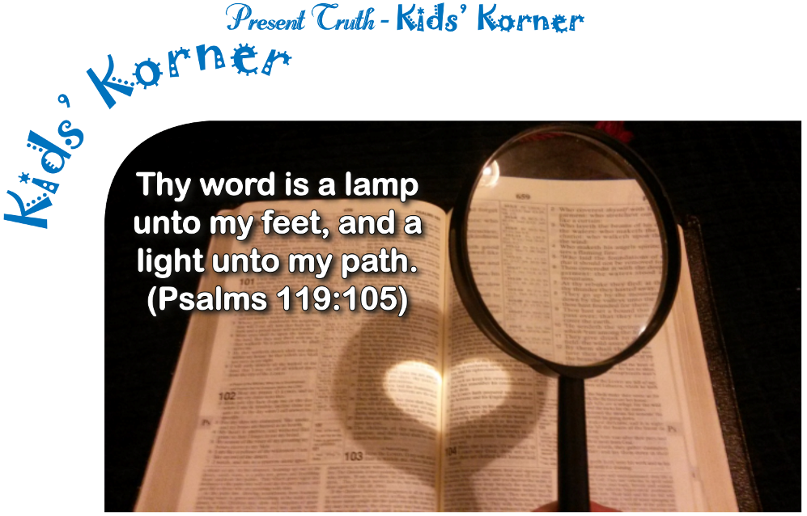

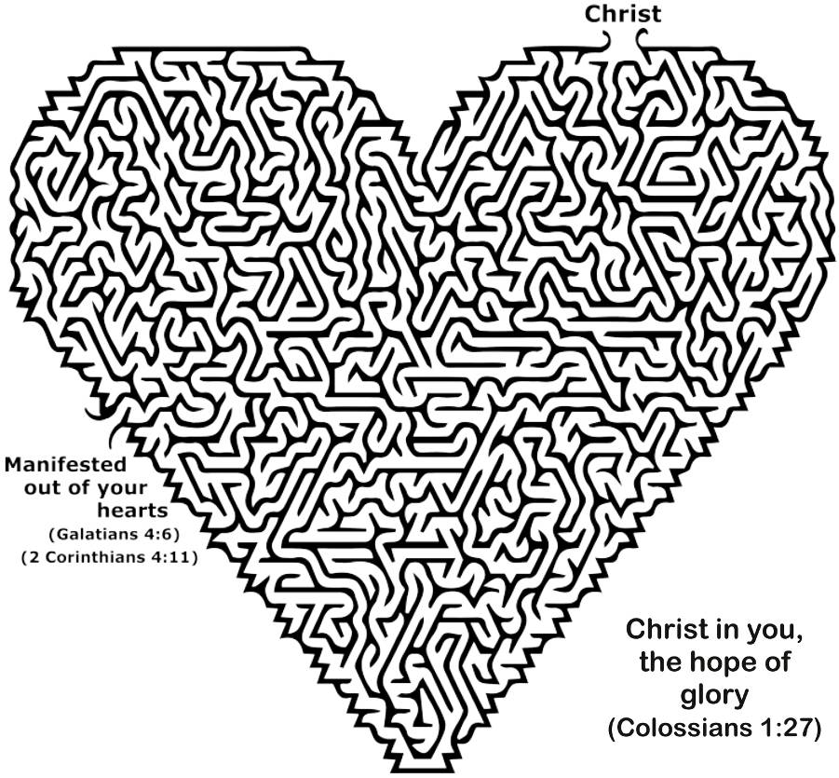

Bible Word Search
Find the underlined words…
“And because ye are sons, God hath sent forth the Spirit of his Son into your hearts, crying, Abba, Father.” (Galatians 4:6)

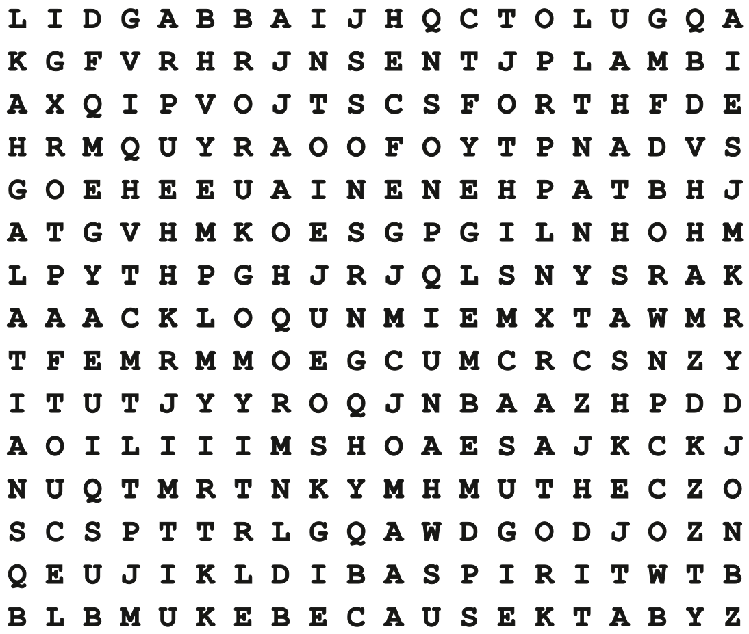

Encouraging Thoughts
The eyes of the LORD are in every place, beholding the evil and the good.
(Proverbs 15:3)

In all thy ways acknowledge him, and he shall direct thy paths.
(Proverbs 3:6)

I will both lay me down in peace, and sleep: for thou, Lord, only makest me dwell in safety.
(Psalm 4:8)

We are troubled on every side, yet not distressed; we are perplexed, but not in despair; Persecuted, but not forsaken; cast down, but not destroyed; Always bearing about in the body the dying of the Lord Jesus, that the life also of Jesus might be made manifest in our body. For we which live are alway delivered unto death for Jesus’ sake, that the life also of Jesus might be made manifest in our mortal flesh.
(2 Corinthians 4:8-11)

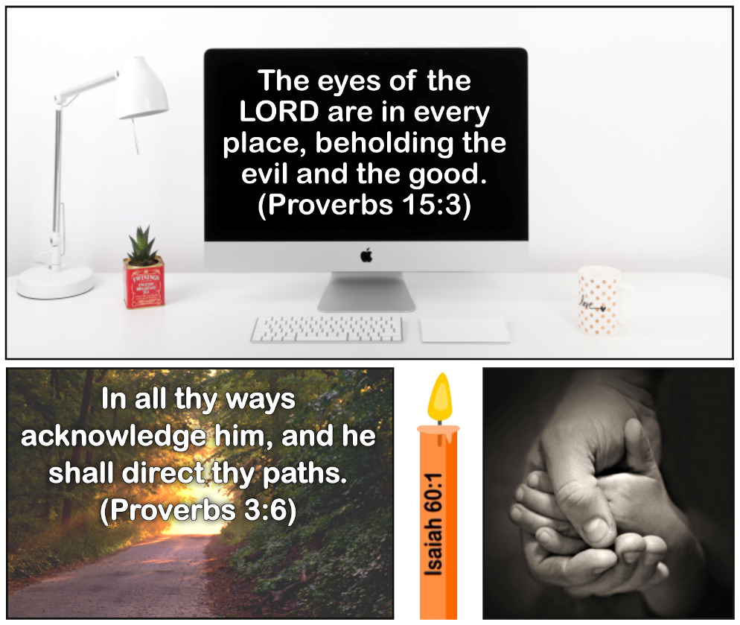

Bible Study Crossword – Finding Your Identity - Part 2
(The King James Version is required.)

To complete this crossword, please download the PDF version of this newsletter.



› God loves you “with an ____ love.” Jeremiah 31:3—2 Down
› “According as his divine power hath given unto us all things that pertain unto life and ____,…” 2 Peter 1:3—1 Across
› “…through the ____ of him that hath called us to glory and virtue.” 2 Peter 1:3—9 Down
› “Whereby are given unto us exceeding great and precious ____:…” 2 Peter 1:4—6 Across
› “…that by these ye might be partakers of the divine ____,…” 2 Peter 1:4—11 Down
› “…having ____ the corruption that is in the world through lust.” 2 Peter 1:4—7 Down
Note: Grace is “the divine influence upon the heart, and its reflection in the life” (Strong’s Greek Dictionary).
› God “…hath made us ____ in the beloved.” Ephesians 1:6—4 Down
› “In whom we have ____ through his blood, the forgiveness of sins,…” Ephesians 1:7—16 Across
› “…according to the riches of his ____.” Ephesians 1:7—15 Across
› Jesus prayed to His Father, “…that the world may know that thou hast sent me, and hast ____ them, as thou hast ____ me.” John 17:23 (1 word)—12 Across
Note: Believe in your status as a beloved child of the Most High, and your life will reflect that belief.
› “For a just man falleth ____ times, and riseth up again: but the wicked shall fall into mischief.” Proverbs 24:16—3 Down
› “Rejoice not against me, O mine enemy: when I fall, I shall ____;…” Micah 7:8—14 Across
› “…when I sit in darkness, the Lord shall be a ____ unto me.” Micah 7:8—13 Down
› “If we confess our sins, he is faithful and just to ____ us our sins,…” 1 John 1:9—10 Down
› “…and to ____ us from all unrighteousness.” 1 John 1:9—5 Across
› Jesus said, “…him that cometh to me I will in no wise ____ out.” John 6:37—8 Across

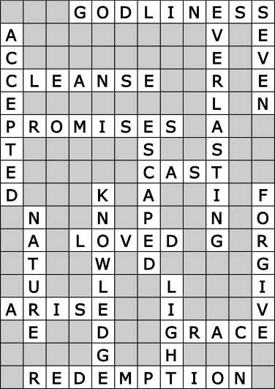



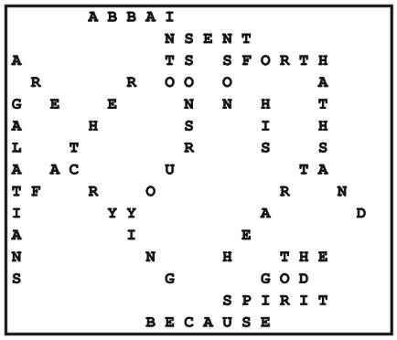

Bonus
How many times can you find the word “fallen” in the first article? ______
Answers for the Last Issue: Everlasting 11
_______________________________________________________________________________

Present Truth is non-denominational Bible-study paper published by Present Truth Fellowship. It is sent free upon request. Duplication is not only permitted but strongly encouraged, as long as our contact information is retained and the content is unchanged. Present Truth is available online at www.PTFellowship.org, and you may also request to receive it by e-mail.
Note: If you move, please send us your new address. If you inadvertently get deleted from our mailing list, without your request, please write us and verify your valid address.
Editor: Lynnford Beachy, PO Box 315, Kansas, OK 74347, phone: (304) 633-5411, e-mail: newsletter@PTFellowship.org.

